**Lab Discovery Tool**

1. **Overview**

The purpose of this tool is to consolidate different ways for tracking lab data.

Modules that the final tool will be handling are:

* SAN (Storage Area Networks)
* Lab maps and racks layout
* IP database
* Team wiki.

The module that is being developed in this face is SAN.

Around ten thousand connections are being tracked on spreadsheets. This system works but is very limiting as just one person can work on the spreadsheets at the time.

There are also multiple formulas in place to get data from different sources, this slows down Excel, and sometimes data is lost if not saved continuously.

Having a most effective way of handling data by using a database and creating user friendly interface will improve the team efficiency.

1. **Screen-by-screen design layouts for SAN module**
2. Login: Intended for authentication and defining roles, admin and regular users.

Accounts with admin roles will be able to validate and modify data.

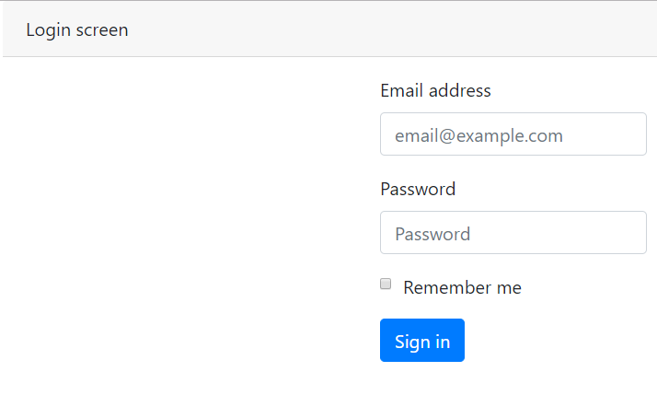

1. Dashboard: Users can select what module of the tool they want to access. It will have “Import” and “Add” options for users with admin role

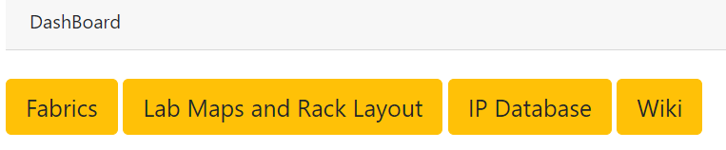

1. Fabrics Module: User have to options: Search to get information about existing connections and Reserve Ports to add new connections.

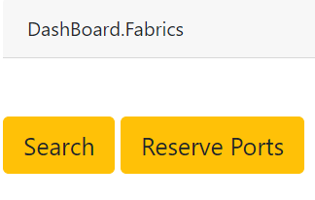

1. Search inside the Fabrics module: Users will be able to search connections by system name (all connections for that system) or wwn (a specific connection of a system). The information will be displayed

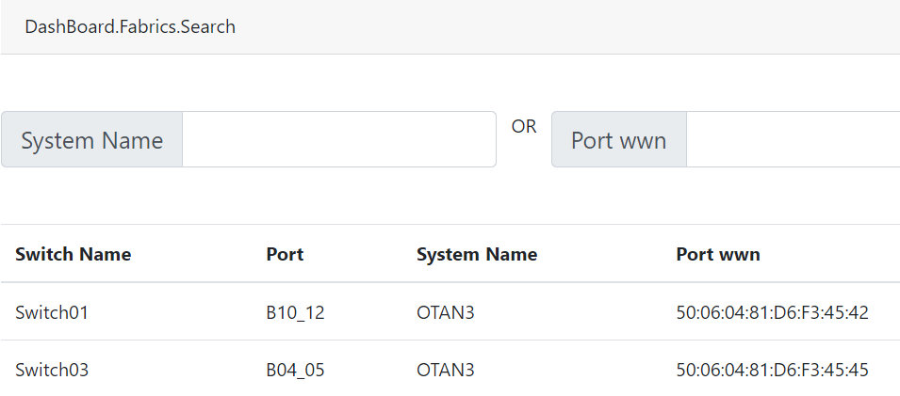

1. Reserve Port inside the Fabrics module: users will need to specify what lab they need the ports for. Then they can select from the available switches within that lab, and all available ports will be displayed. User will select the ports and click “Reserve” to continue.

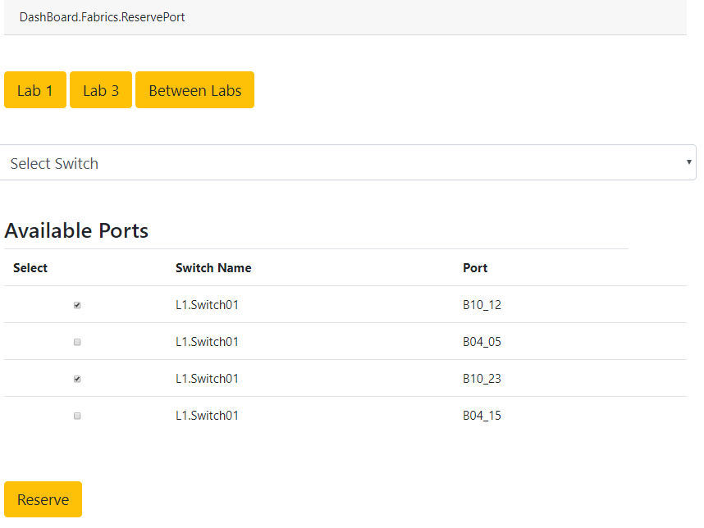

1. Reserve button: users will need to enter information about the request and system that the connections are going to be used for. Once the information is complete for all ports requested, information about the reservation will be displayed.

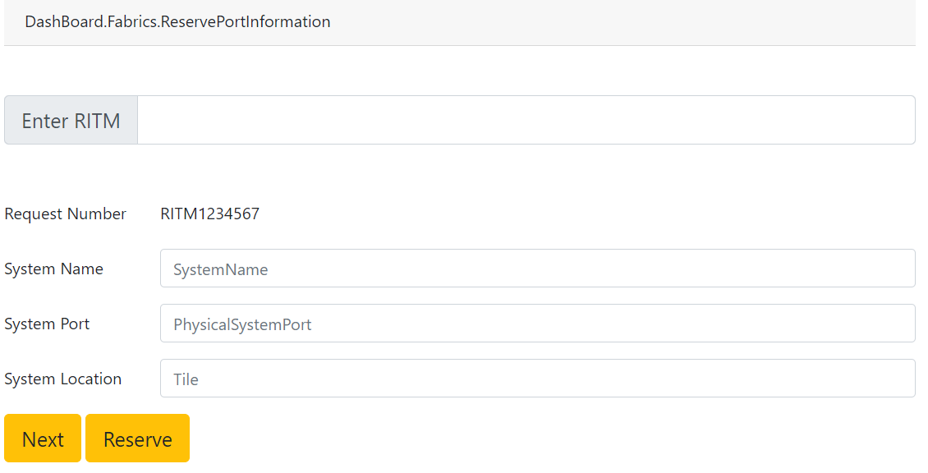

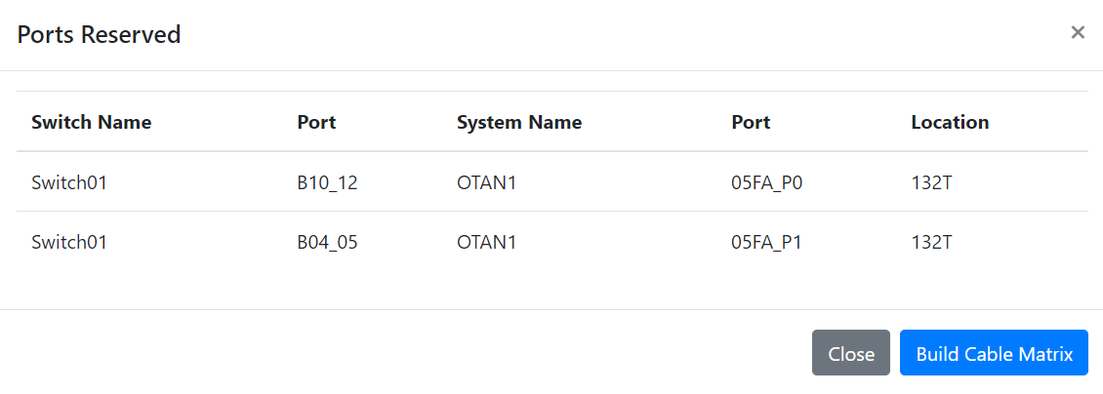

1. **Tasks and schedule**

